Module-3 Image Management & Registry Operations
Docker images
List and understand existing Docker images on your system.
- docker images
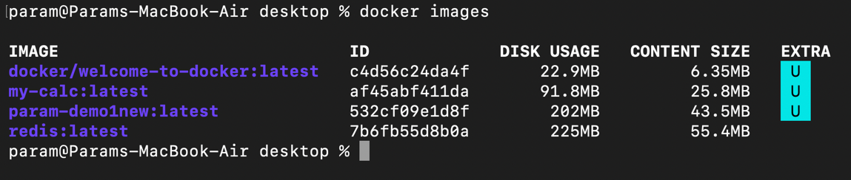
Pull images from Docker Hub and inspect their details.
- docker pull python
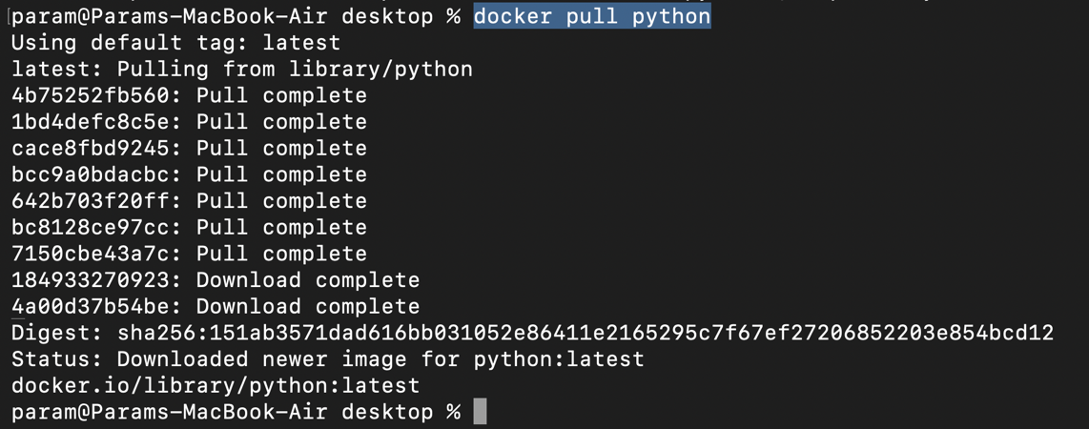
- docker inspect redis
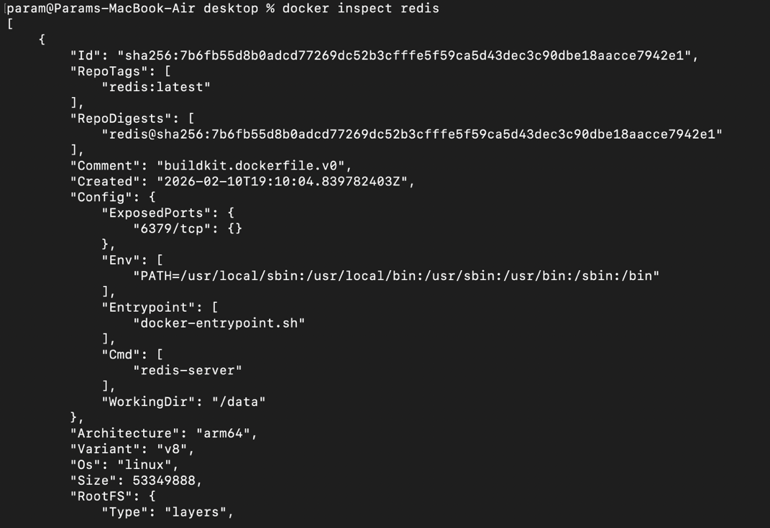

Tag Docker images with custom names and versions.
- docker tag python python3
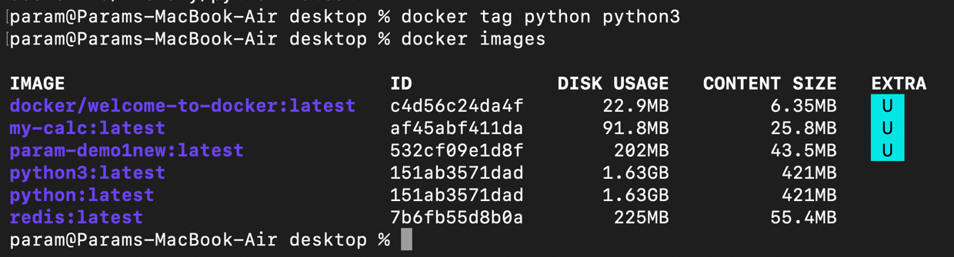
Remove unused or unwanted images to keep the system clean.
- docker rmi python3
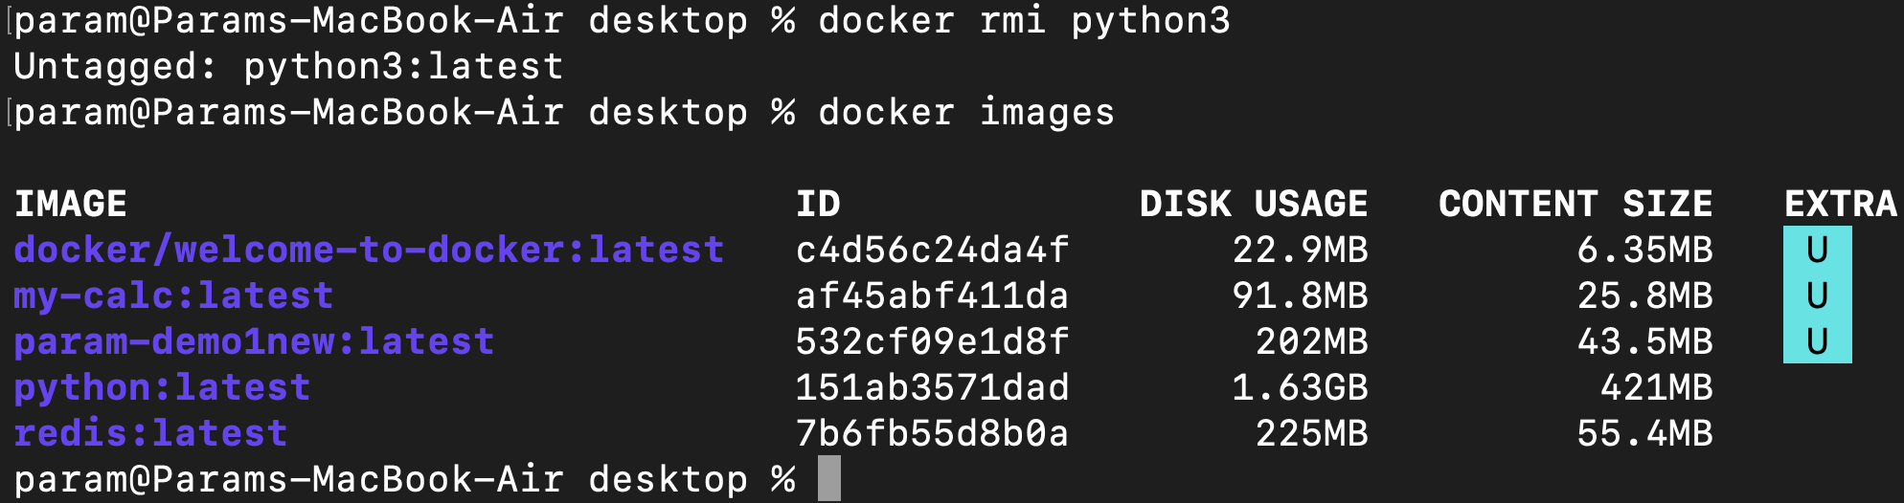

Container Commit

Run a container from an existing image.
- docker run -d -p 5500:80 my-calc
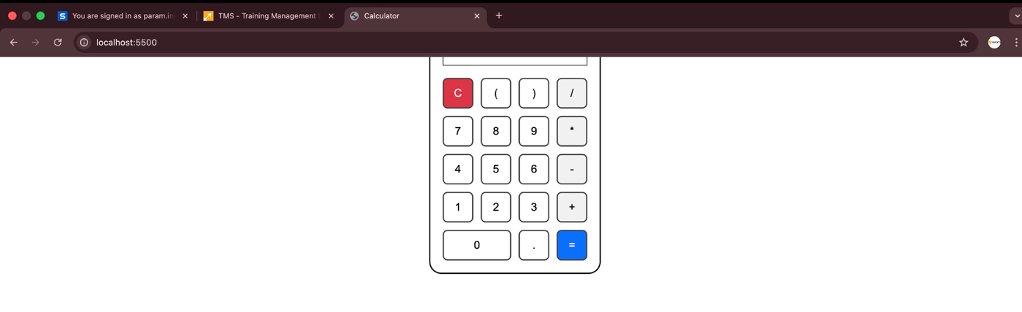

Make a small change inside the running container (for example, install a package or update a file).
- docker exec -it heuristic_davinci /bin/sh

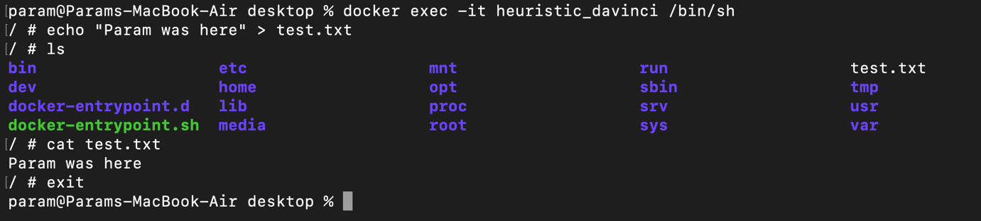

Create a new Docker image from the modified container using the commit process.

- docker commit heuristic_davinci commit-container1
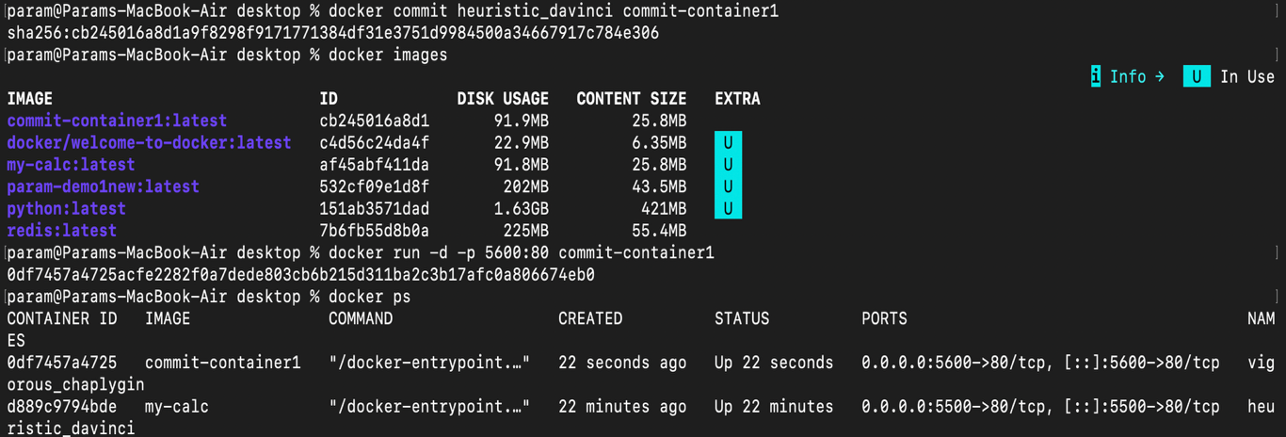
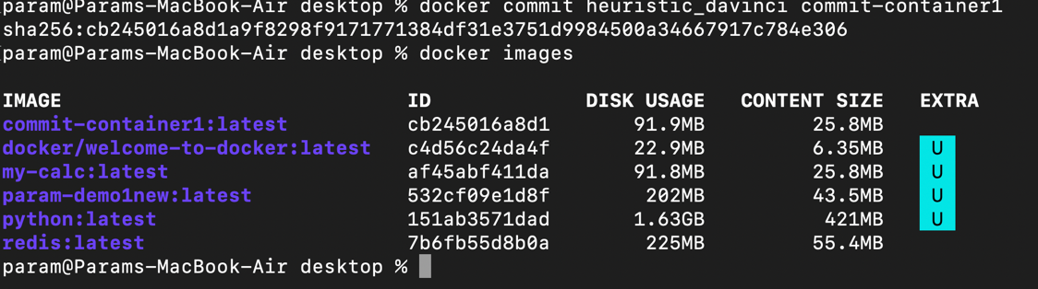

Q. Explain the difference between using docker commit and creating images using a Dockerfile, and mention when docker commit should be avoided.

docker commit creates an image from a running container’s current state, but it is not reproducible or version-controlled.
A Dockerfile defines step-by-step instructions to build an image, making it consistent, reusable, and team-friendly.
docker commit should be avoided in production or team projects where reproducibility and maintainability are important and should only be implemented when doing experiments or debugging.

Container registry
Log in to Docker Hub from the command line.
- docker login -u paramdholakia
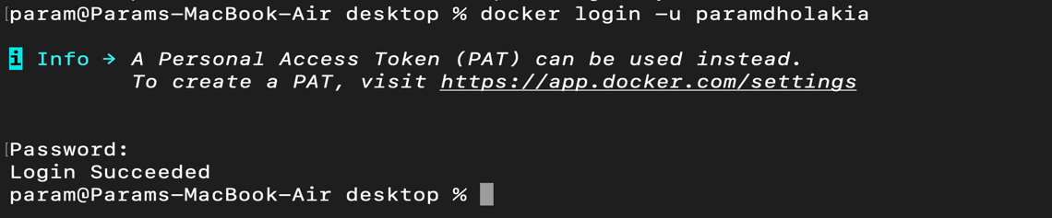
Push the newly created or tagged image to Docker Hub.
- docker push paramdholakia/my-calc
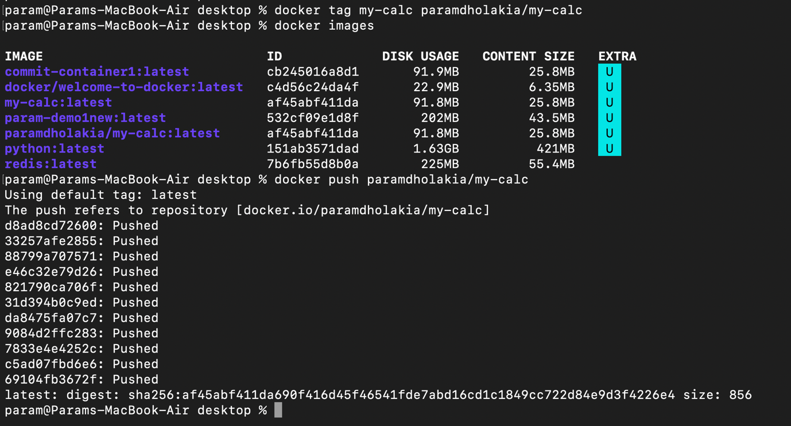
Pull the same image back from the registry to verify it was uploaded successfully.
- Deleted all containers
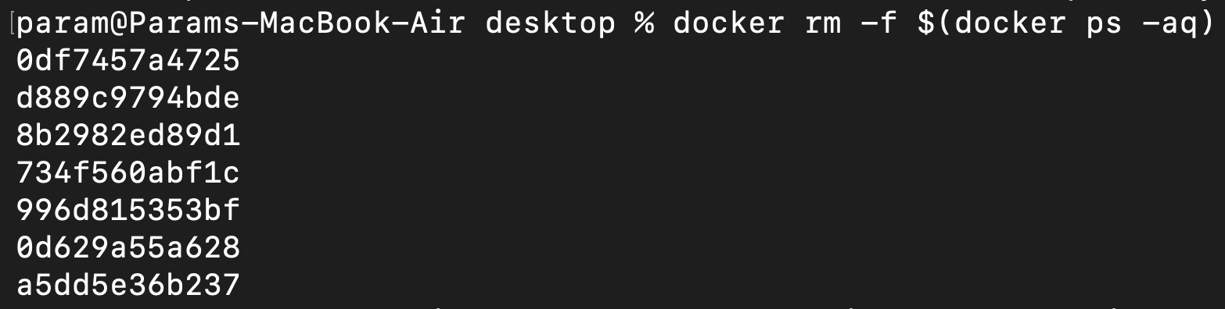

- Deleted all images
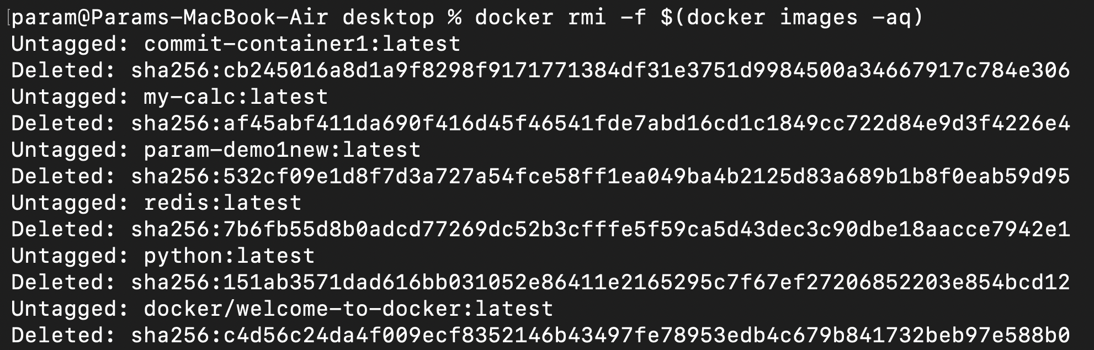
- Checking images if any exists
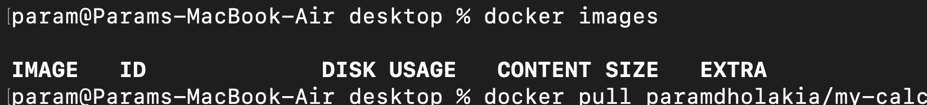
- docker pull paramdholakia/my-calc
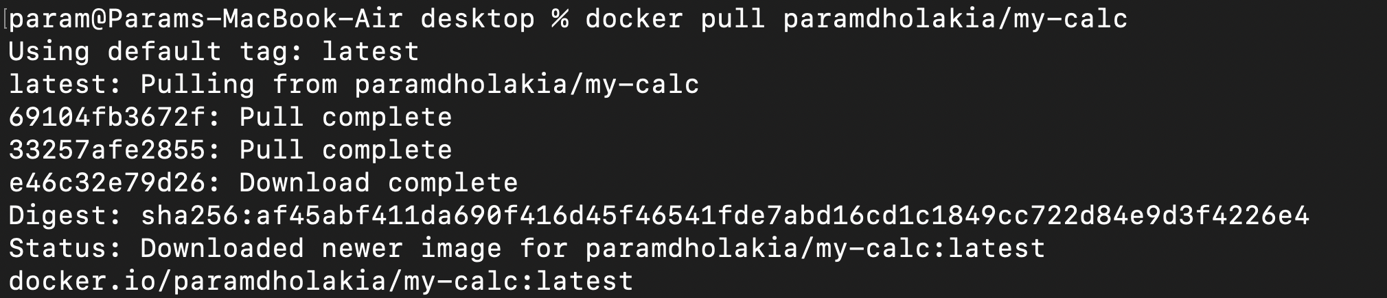
- rechecking images
